Grid-Powered LED Highway Street Lighting System

- Problem Statement and System Requirements
1.1 Problem statement
The manual operation of streetlight systems often leads to significant energy wastage when lights are left on during daylight hours, or safety hazards when they aren't turned on promptly at night.
Existing automated systems frequently suffer from:
- Fixed Thresholds: They cannot adapt to varying weather conditions and seasonal variations in daylight hours (like heavy overcast or storms).
- Lack of Flexibility: There is often no way to bypass the sensor for maintenance or emergency situations.
- Sensitivity Issues: Rapid flickering caused by momentary shadows or car headlights.
This project aims to design an automatic, reliable, adjustable controller that optimizes energy usage by responding to ambient light levels while providing manual control for maintenance.
1.2 Operating Environment
The controller will be installed in weatherproof enclosures mounted on streetlight poles or utility boxes. It must withstand temperature variations, humidity, dust, and occasional mechanical vibrations. The system requires protection against outdoor environmental conditions including rain, UV exposure, and electromagnetic interference from nearby power lines.
1.3 System Inputs & Outputs
1.3.1 Inputs
- Light Sensor: A Light Dependent Resistor (LDR) or a Photodiode to monitor ambient lux levels.
- Threshold Adjustment: A potentiometer (variable resistor) to allow the user to set the specific "darkness" level for activation.
- Manual Override: A 3-position physical toggle switch or push-button (Auto/Manual-ON/Manual-OFF).
1.3.2 Outputs
- Actuator: An electromagnetic Relay or Solid-State Relay (SSR) to switch the high-voltage AC lamp circuit.
- Status Indicators: LEDs to show system status
1.3.3 Power Supply
- 12V DC (from regulated adapter or battery)
  - Design Requirements
Parameter | Specification
Light Detection Range | 1 lux – 1000 lux
Threshold Adjustment | Threshold should be adjustable between 10 lux (deep dusk) and 100 lux (overcast day).
Response Time | ≤ 5 seconds switching delay after threshold detection with a 5–10 second delay (hysteresis) to prevent false triggering caused by lightning, car headlights or clouds.
Accuracy | ±10% light level measurement
Reliability | ≥ 50,000 hours continuous operation (approximately 5.7 years)  ≥ 100,000 switching cycles
Light source | LED luminaire
Control | Mechanical Relay
Protection rating | IP66 (outdoor, dust and waterproof)

2.0 System Block Diagram
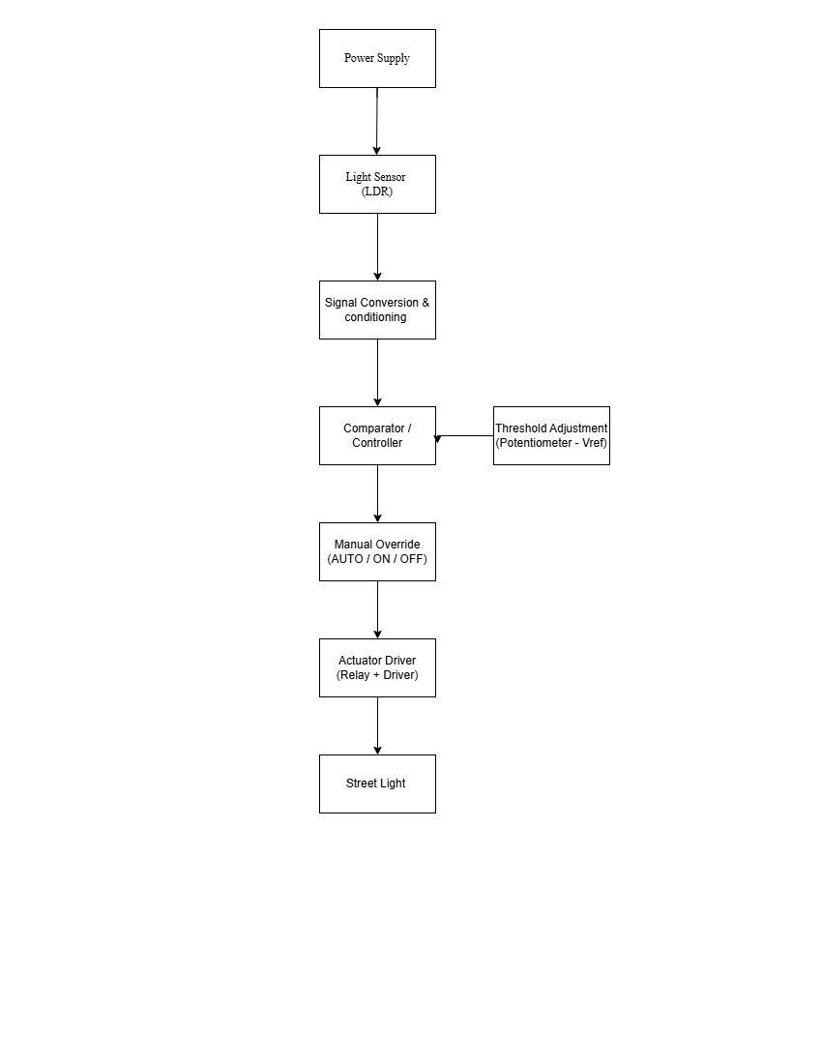
2.1 Block Descriptions
  - Power Supply: A 12V DC regulated supply powers the control circuit. A 7805 voltage regulator provides stable voltage. A 5V rail derived via a 7805 regulator powers the micro-controller.
  - Sensing Stage: An LDR forms a voltage divider with a fixed resistor (R1 = 10kΩ). As ambient light intensity decreases (nightfall), the LDR resistance increases.
  - Controller Stage: An Arduino micro-controller reads the input from the sensor and compares it with set threshold from the potentiometer and then controls the relay.
  - Manual Override Stage: A 3-position SPDT switch allows the user to select: AUTO (sensor controls the lamp), FORCE-ON (lamp always ON regardless of light level), or FORCE-OFF (lamp always OFF for maintenance).
  - Relay Driver: The controller output drives an NPN transistor (BC547) which switches a 12V relay coil. A 1N4007 flyback diode across the relay coil suppresses the back-EMF spike when the relay de-energizes, protecting the transistor.
  - Street Lamp: The relay's normally-open (NO) contacts connect the mains supply to the streetlight. When the relay energizes (night detected), the lamp turns ON.

3.0 DESIGN CHOICES AND JUSTIFICATION
This section details the selection of hardware components and control logic for the streetlight controller. Each choice is made to ensure the system aligns with the specific performance requirements for reliability, environmental resilience, and energy optimization.
3.1.1 Transducer Selection: Light Dependent Resistor (LDR)
To monitor ambient lux levels within the required 1 lux to 1000 lux range, a Light Dependent Resistor (LDR) has been selected as the primary transducer.
- Sensitivity and Spectrum: LDRs are highly sensitive to visible light, making them ideal for detecting the transition between "deep dusk" (10 lux) and "overcast" conditions (100 lux).
- Cost-Efficiency: Compared to high-precision photodiodes, LDRs offer a cost-effective solution for widespread municipal deployment without sacrificing the necessary accuracy.
- Integration: The LDR integrates seamlessly with the R-V filter for signal conditioning, converting light intensity into a readable voltage level for the controller.
3.1.2 Switching Element: Electromechanical Relay
The system will utilize an Electromechanical Relay to interface between the low-voltage control logic and the high-voltage AC lamp circuit.
- Durability: The chosen relay meets the reliability requirement of 100,000 switching cycles, which is essential for a system designed for over 5 years of continuous operation.
- Thermal Management: Unlike semiconductors like SCRs, mechanical relays do not require extensive heat sinking to manage the streetlight load, allowing the controller to remain within the 5W power consumption limit.
3.1.3 Actuation Method: Relay Output
The actuation method is defined as a Relay Output configuration, where the controller drives the relay coil to open or close the lamp circuit.
- Application Suitability: While steppers or micromotors are used for mechanical positioning, a relay output is the industry standard for binary "ON/OFF" switching of electrical grids.
- System Indicators: This method allows for the simultaneous triggering of status LEDs to provide clear visual feedback of the actuator state.

3.1.4 Controller Type: Microcontroller (MCU)
A Microcontroller is selected as the central "Comparator/Controller" unit.
- Hysteresis and Logic: An MCU is necessary to implement the required 5–10 second delay (hysteresis) to prevent false triggering or rapid flickering caused by momentary shadows or car headlights.
- Adjustable Thresholds: The MCU processes the analog input from the threshold adjustment potentiometer, allowing the user to set the activation point between 10 lux and 100 lux.
- Manual Override Integration: The MCU monitors the 3-position toggle switch (Auto/Manual-ON/Manual-OFF) to instantly bypass sensor logic for emergency or maintenance situations.

4. Protection, Safety and Reliability
Relay Coil Protection
Flyback diode (1N4007) connected in reverse bias across the relay coil terminals. Clamps the back-EMF spike to approximately 0.7V above Vcc, protecting the BC547 transistor from breakdown.

Supply Protection
100µF electrolytic capacitor across the 12V supply rail: filters supply noise and transients.
100nF ceramic capacitor at the comparator supply pins: decouples high-frequency interference.
1A fuse on the 12V input line: protects against short circuits in the control board.

Sensor Protection
10kΩ series resistor in the LDR divider limits current through the LDR to safe levels.
LDR mounted in a weatherproof enclosure with a transparent cover to prevent direct water ingress while allowing ambient light measurement.

Mains Side Safety
Mains-side wiring enclosed in a rated enclosure (IP54 minimum).
Mains circuit protected by a separate 6A MCB upstream.

Reliability Features
Hysteresis eliminates relay chatter (rapid ON/OFF cycling) which is the primary cause of relay contact wear and lamp filament failure.
Adjustable threshold accommodates ageing of the LDR (sensitivity drift over years).
Manual override ensures the system remains functional even if the LDR or comparator fails, maintenance can force the lamp ON manually.

- TEST PLAN (VALIDATION PLAN)
The following tests validate system functionality under normal and fault conditions. Each test includes pass/fail criteria and required measurement equipment.
# | Test Name | Procedure | Measurement | Pass/Fail Criteria
1 | Darkness Trigger | Gradually cover the LDR with an opaque material | Digital Multimeter (DMM) across Relay output. | Relay clicks and Load turns ON when LDR is dark.
2 | Daylight Cut-off | Expose the LDR to a bright light source (Flashlight/Sun). | Voltage at Relay Coil. | Relay clicks and Load turns OFF when LDR is illuminated.
3 | Threshold Range | Turn the Potentiometer to Min/Max and repeat Test 1. | Lux meter vs. activation point. | Trigger timing changes significantly based on knob position.
4 | Manual Override (ON) | Set 3-way switch to "Manual ON" during broad daylight. | Continuity or Load state. | Light turns ON immediately, bypassing all sensor logic.
5 | Manual Override (OFF) | Set 3-way switch to "Manual OFF" during pitch black. | Continuity or Load state. | Light turns OFF immediately, bypassing all sensor logic.
6 | Transient Shadow | Briefly pass a hand over the LDR (mimicking a bird flying over). | Stopwatch / Relay observation. | No switching occurs. The software delay ignores pulses < 5 seconds.
7 | Sensor Fault (Open) | Disconnect one wire from the LDR to simulate a broken lead. | Relay state observation. | System defaults to "Lights ON" (Fail-safe for public safety).
8 | Short Circuit Test | Briefly bridge the load side with a high-current load. | Physical fuse inspection. | The 5A fuse blows instantly, preventing damage to the relay.
9 | Thermal Resilience | Place the control box in a heat chamber or direct sun for 4 hours. | Internal thermometer/Probe. | Logic remains stable; enclosure shows no deformation or overheating.
10 | Hysteresis Recovery | Keep light level exactly at the threshold for 60 seconds. | Relay "chatter" (rapid clicking). | Relay switches ON once and stays ON; no rapid oscillations (chatter) allowed.

